Curriculum Vitae

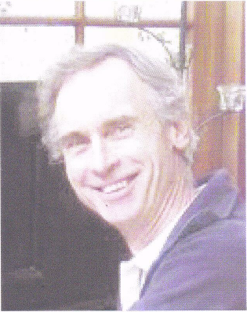
Contact details
Mobile: Email:
Richard Moore

0429 926 731
richard.w.moore2@gmail.com
Personal details
Name: Richard William Moore
Address:
Date of Birth: Place of Birth: Nationality:
341 Yungarra Drive Quedjinup WA 6281
8 November 1951 Hobart, Tasmania
Australian

Educational qualifications
1997 Graduate Certificate in Farm Forestry, University of Melbourne

1974
Employment
2005 to 2009
2004 & 2005 1995 to 2004 1979 to 1995 1978 1975 to 1977
Bachelor of Science (Forestry), Australian National University
Manager, Community Tree Farming, Forests Products Commission State Farm Forestry Coordinator, Trees South West, Bunbury Technical Manager, Farm Forestry Unit, CALM, Busselton Research Scientist (Agroforestry), Forests Department of WA Nursery and forest operations, Hakadal, Norway Native forest management, Forest Department of WA, Dwellingup

